TASK 1:

#include<iostream>

using namespace std;

int main()

{

int a,b;

int *ptra,*ptrb;

cout<<"Enter 1st integer "<<endl;

cin>>a;

cout<<"enter 2nd Integer"<<endl<<endl;

cin>>b;

*ptra=a;

*ptrb=b;

cout<<"The value stored in first pointer is "<<*ptra<<endl;

cout<<"the value stored in second pointer is "<<*ptrb<<endl;

return 0;

}

# SNIP

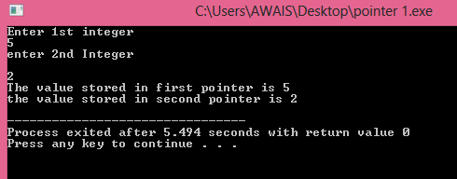

Task 2

#include<iostream>

using namespace std;

int main()

{ int max[100];

int wada=0;

int *pointer;

pointer=&wada; //pointing pointer towards max

int enteries,eachValue;

cout<<"Enter the number of entries you want to enter in the set "<<endl;

cin>>enteries;

cout<<"Enter each value element"<<endl;

for(int i=0;i<enteries;i++)

{

cin>>eachValue;

if (eachValue>wada )

{

wada=eachValue;

}

}

cout<<"The max number using the pointer finding"<<endl;

cout<<*pointer;

return 0;

}

Task 3

#include<iostream>

using namespace std;

int main()

{

int Array[5]; //because we cannnot take input in the pointer array

int *pointer=Array;

cout<<"Please input the array of 5"<<endl;

for(int i=0;i<5;i++)

{

cin>>Array[i];

}

for (int i=0;i<5;i++)

{

cout<<*pointer;

pointer++;

}

return 0;

}

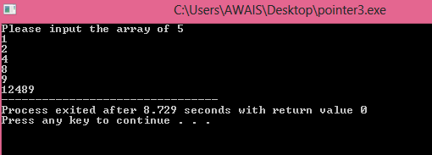

Task 4

#include<iostream>

using namespace std;

int panga(char array[],char *pointer,int size)

{

for(int i=0;i<size;i++)

{

if(pointer==&(array[i]))

{

return i;

}

else

return -1;

}

}

int main()

{

char array[100], *pointer;

int size=0;

cout<<"ENTER THE SIZE OF AN ARRAY :"<<endl;

cin>>size;

cout<<"ENTER THE DESIRE CHARACTER :"<<endl;

cin>>array;

ptr=array;

cout<<check(array,pointer,size)<<endl;

system("pause>0");

}